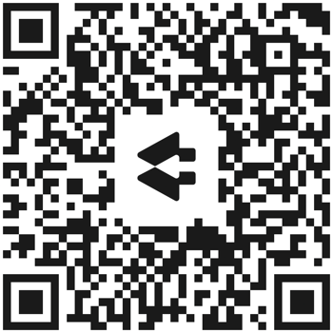

This link and QR Code will send you
to all things Fiddlers2 in one spot.

https://linktr.ee/fiddlers2

Please Join Us for a House Concert
Featuring “Fiddlers2”

Sunday, September 11
At the home of (your name)
1 Melody Lane, Reno, NV 89234

Time: 6:00 p.m. Gate to Backyard Opens
7:00 p.m. Showtime
Price: $20 per ticket to be paid at the door (100% goes to the musicians).
Complimentary light dessert, soda, white & red wine provided.
Libations: If you prefer, please feel free to B.Y.O.B.
R.S.V.P. Space is limited, so please R.S.V.P. by email as soon as possible:
yourname@youremail.com
For questions, contact (your name) 777-777-7777
NOTE: Please bring personal lawn chairs for backyard seating.

Hailing from the West Coast, Nevada-based Celtic band Fiddlers2 brings an unforgettable musical experience. Holly Sternberg, three-time Nevada State Fiddle Champion (and winner of the California Western Open), and Vanessa Porter, classical violinist extraordinaire, are excited to be performing for you.

Music touches people's souls. It creates a bridge that reaches across space and time, through generations and memory, and between the hearts of those who listen. Though they come from very different backgrounds, Vanessa and Holly joined as Fiddlers2 to create a truly unique interweaving of Irish, Scottish, and Cape Breton music. With a nod to tradition and the added flair of their own contemporary arrangements, they harmoniously blend their Classical and Celtic styles, breathing life into music that touches every range of human emotion, from the most profound sorrow to the most inspiring joy.

