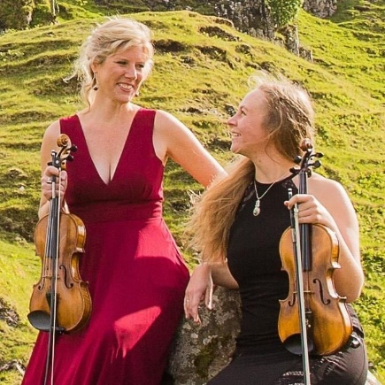
Please Join Us for a House Concert
Featuring “Fiddlers2”
From Reno, Nevada

Tuesday, June 21, 2022
Home of Keith and Cathy Shannon
100 Melody Lane, Lebanon, IL

Time: 6:00 p.m. Doors Open
7:00 p.m. Showtime
9:00 p.m. Irish Session Begins (session musicians are encouraged to bring instruments).
This session is open to all who want to play, listen, or just visit.

Price: $20 per ticket to be paid at the door (100% goes to the musicians).
Complimentary light appetizers, dessert, coffee, soda, Sangria, and Whiskey Slush provided.

Libations: Guinness, Harp, and 4204 Pecan Brown will be available on draft along with wine and whiskey, all for $5.00 each (cash only). If you prefer, please feel free to B.Y.O.B.

R.S.V.P. Space is limited, so please R.S.V.P. by email as soon as possible yourname@?.com.
For questions, contact Cathy at 777-777-7777.

Hailing from the West Coast, Nevada-based Celtic band Fiddlers2 brings an unforgettable musical experience. Holly Sternberg, three-time Nevada State Fiddle Champion (and winner of the California Western Open), and Vanessa Porter, classical violinist extraordinaire, are excited to be performing for you.

Music touches people's souls. It creates a bridge that reaches across space and time, through generations and memory, and between the hearts of those who listen. Though they come from very different backgrounds, Vanessa and Holly joined as Fiddlers2 to create a truly unique interweaving of Irish, Scottish, and Cape Breton music. With a nod to tradition and the added flair of their own contemporary arrangements, they harmoniously blend their Classical and Celtic styles, breathing life into music that touches every range of human emotion, from the most profound sorrow to the most inspiring joy.

This link and QR Code will send you to all things Fiddlers2 in one spot.

https://linktr.ee/fiddlers2

